

Helping the Blind commute to Work.

Group K Information: 1

Introduction 2

1.1. Project Overview 2

1.2. Commuting Challenges and Interaction Design 2

Project Idea 3

2.1. Concept and Rationale 3

2.2. Background Research and Existing Solutions 3

User Analysis 4

3.1. Target Audience 4

3.2. User Needs and Engagement 4

3.3 User Benefits 5

Conclusion 5

4.1. Summary and Future Directions 5

References 5

Appendices 6

6.1. Supplementary Materials 6

# Group K Information:

Group Names:

* Mohamed Ahmed Abdalla
* Abdisalaam Dahir
* Ilyaas Osman
* Sadde Aden
* Tomi Akinyemi
* Faysal mohamed

# Introduction

## 1.1. Project Overview

Our project aims to enhance the commuting experience for the visually impaired, making it safer, more accessible, and efficient for them.

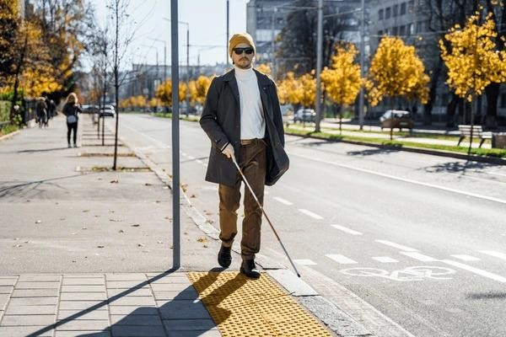

## 1.2. Commuting Challenges and Interaction Design

Challenges:

* **Navigation:** Difficulty in navigating complex transit systems and obtaining real-time transit information.
* **Safety:** There is increased safety risk in crowded or unfamiliar transit environments.
* **Information Accessibility:** Ensuring relevant commuting information is accessible in non-visual formats.

Interaction Possible Design Solutions:

* **Intuitive Navigation Tools:** Designing apps or devices with audio guidance and haptic feedback to aid in station navigation and route finding.
* **Safety Mechanisms:** Features like audio alerts for upcoming stops or hazards, and emergency assistance options.
* **Accessible Information Delivery:** Implementing real-time transit updates and information through auditory channels and braille interfaces.

# Project Idea

## 2.1. Concept and Rationale

Our project, "Helping the Blind Commute to Work," introduces a technological solution designed to assist visually impaired individuals during their daily commute. The concept is a mobile application equipped with features that cater specifically to the needs of blind or visually impaired commuters.

## 2.2. Background Research and Existing Solutions

|  |  |  |  |
| --- | --- | --- | --- |
| **Aspect** | **Existing Solutions** | **Examples** | **Gaps and**  **Opportunities** |
| Navigation Aids | White canes, guide dogs, Braille signs. | White cane with ultrasonic sensors and smart harness for guide dogs. | Lack of integration with public transit systems. |
| Voice-Guided Systems | Google Maps (voice guidance), Apple Maps (voice-over feature). | VoiceOver on iOS, TalkBack on  Android devices. | Not tailored for the specific challenges of commuting, such as crowded environments. |
| Haptic Technology | Sunu Band (sonar wristband), Haptic gloves. | Vibrating navigation belts, smart shoes with vibrational feedback. | Underutilized in the context of public transportation and  has potential for a more focused application. |
| Public Transit Apps | Moovit, Citymapper (route planning for sighted users). | Transit app with voice control and large text options. | Limited accessibility features for visually impaired users. |

# User Analysis

## 3.1. Target Audience

**Visually Impaired Commuters:**

* Individuals who are blind or have significant visual impairments.
* The regular users of public transportation for commuting to work.

**Support Networks:**

* The families and caregivers of visually impaired individuals.
* Organizations and support groups advocating for visually impaired persons.

## 3.2. User Needs and Engagement

Needs:

Effective Navigation: To navigate public transportation systems with confidence, visually impaired users need accurate, real-time navigation assistance. Clear and comprehensible information is necessary for these tools to prevent confusion and guarantee safe travel.

Information Accessible: It's critical to have access to information. This comprises information in conveniently accessible formats, such auditory announcements or tactile feedback devices, regarding schedules, delays, and route modifications.

Engagement:

User Testing: Throughout the development phase, interact with visually impaired users to get their comments and conduct tests. Real-world testing situations can offer priceless insights into the app's usability and applicability.

Feedback Loops: Create in-app tools that let users quickly report issues, offer feature suggestions, and share their thoughts about the app. Iterative advancements will depend heavily on this continued engagement.

## 3.3 User Benefits

Our project offers significant benefits to the users being:

Independence – Users will be able to regain their independence, to have the ability to travel freely of their own accord without having to rely on external assistance on their journeys on public transport.

Safety – Users will be alerted of hazards in their surroundings to aid in their safe travel around the London transport network.

Time saving – By streamlining the process of travel users will be able to save time through the simplification of their daily journeys.

# Conclusion

## 4.1. Summary and Future Directions

The project will aid visually impaired commuters, integrating voice guidance, user feedback, and user-friendly transit apps. Moving forward, our focus will be on prototyping, user testing and collaborating with the visually impaired to create the best experience for them.

# References

* Government of the United Kingdom. (2023). Disability, Accessibility and Blue Badge Statistics: England 2022 to 2023. [online] GOV.UK. Available at: https://www.gov.uk/government/statistics/disability-accessibility-and-blue-badgestatistics-2022-to-2023 [Accessed 4 Feb. 2024].
* Scherffig, L., & Wahl, S. (2022). The Unfolding Space Glove: A Wearable Spatio-Visual to Haptic Sensory Substitution Device for Blind People. [online] MDPI. Available at:

<https://www.mdpi.com/1424-8220/22/5/1859>[Accessed 3 Feb. 2024].

* Kapfunde, M. (2017). The Sunu Band, a Wearable Tech Device for the Visually Impaired. [online] FashNerd. Available at: [https://fashnerd.com/2017/08/sunu-bandwearable-tech-visually-impaired/](https://fashnerd.com/2017/08/sunu-band-wearable-tech-visually-impaired/) [Accessed 3 Feb. 2024].
* Santos, G., & Nikolaev, N. (2021). Mobility as a Service and Public Transport: A Rapid Literature Review and the Case of Moovit. [online] MDPI. Available at: <https://www.mdpi.com/2071-1050/13/7/3666>[Accessed 3 Feb. 2024].
* Wakana Sugiyama. (2019). Voice guidance in Maps, built for people with impaired vision. [online] Google. Available at: [https://blog.google/products/maps/better-mapsfor-people-with-vision-impairments/](https://blog.google/products/maps/better-maps-for-people-with-vision-impairments/) [Accessed 3 Feb. 2024].

# Appendices

## 6.1. Supplementary Materials

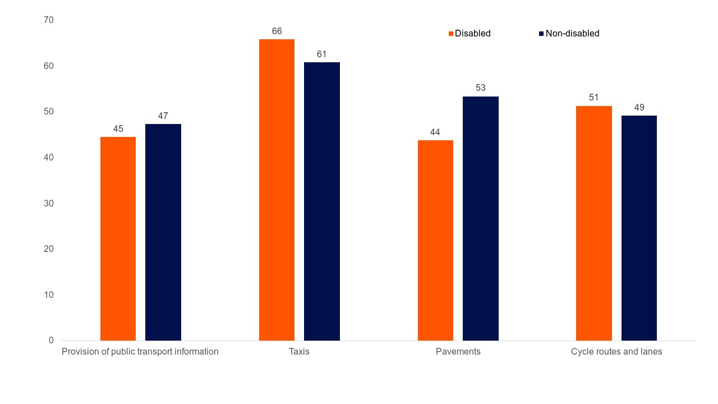

*Figure 1: Chart 1: Percentage of people satisfied with various aspects of public transport, by disability status: England outside London, 2022*

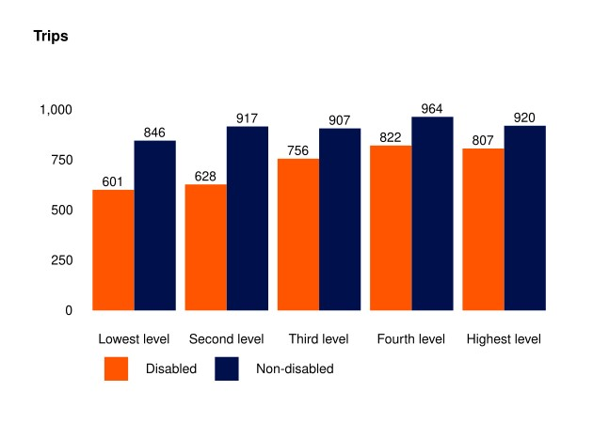

*Figure 2: Chart 7: Number of trips per person by disability status and income quintile: England, 2022 – DIS0409*

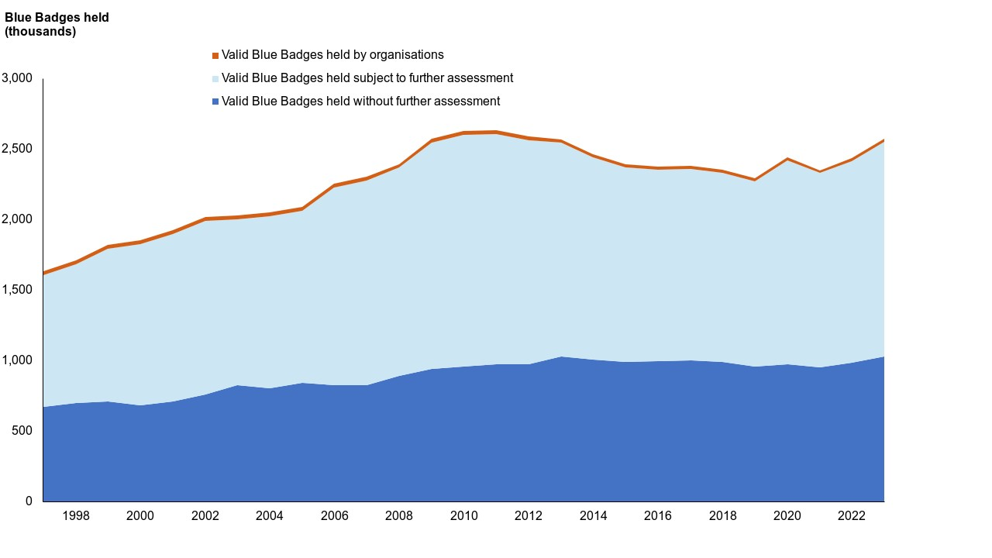

*Figure 3: Chart 10: Blue Badges held: England, annually since March 1997 – DIS0101*

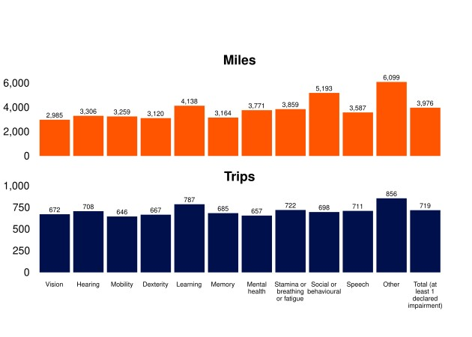

*Figure 4: Chart 6: Average miles travelled, and trips made by type of disability, aged 16 and over: England, 2022 - NTS0712*